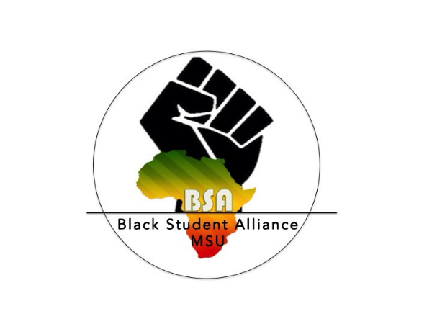
BLACK STUDENT ALLIANCE
2017 – 2018 Executive Board Application

The completed application must be submitted to the BSAemail1@gmail.com at 11:59 PM on March 16th. Please include your resume and a letter of intent with the application.

Requirements:
- All applicants must have a 2.5 cumulative GPA
- All applicants must be a current undergraduate student at Michigan State University
- All applicants must present a speech at elections on March 20th, location TBD.
- If elected, applicants will be required to attend the CORES & COPS executive board retreat taking place March 25th - 26th at the Kellogg Biological Center.

For more information regarding elections, there will be an Executive Board Informational meeting on March 13th at 6 pm in Erikson Kiva.

Purpose: The purpose of Black Student Alliance is to cultivate the unity of MSU’s Black community as a conduit of leadership, academic success, consciousness, and experience.
Vision Statement: The Black Student Alliance aims to ensure the promotion of radical Black love, through collective advocacy, continual support and results driven action, to redefine the Black experience at Michigan State University.

Applications submitted after the deadline will not be considered

Executive Board Position Descriptions
President
- Provide leadership and direction to the organization
- Understand and adhere to the constitution and guidelines
- Establish long and short range goals for objectives and goals with the executive board
- Structure the organization to ensure continuity of leadership by providing opportunities for new leaders to develop and be mentored
- Has the overall financial responsibility of the organization
- Approves all planning from committees and members
- Approves all official communications
- Regularly meet with advisor and vice president
- Regularly meet with MSU administration members and departments
- Maintain working relationships with CORES & COPS presidents and co-chairs
- Maintain working relationships with presidents of Black student organizations
- Maintain relationships with MSU Black faculty, staff, Alumni Association
- Positively represent Black Student Alliance and the overall Black community in the media, public and any speaking engagements
Vice President
- Preside over meetings in absence of the president
- Plan, coordinate, and supervise committees to manage programs and initiatives
- Provide data on past events to benefit from past experiences or suggestions for improvement.
- Provide information on forthcoming events to communications director for inclusion in the newsletters, social media, and mailing
- Ensure strong leadership succession and mentorship to new officers
- Request venues on behalf of the organization
- Manage expectations, performance, and disciplinary action of executive board members
- Regularly meet with advisor and president
Communications Director
- Maintains correspondence of the organization
- Maintains roster and contacts of constitute groups, faculty, staff, and departments
- Keeps record of all meeting minutes and attendance
- Inform officers of deadlines for reports, mailing, or future commitments
- Maintains a complete and up to date copies of organizational documents
- Maintain documentation of significant incidents that occur in relation to BSA and the Black community at MSU.
- Schedule presentations and meeting times for organizations seeking collaboration or funding
- Finds ways to use technology to improve operations

Historian
- Ensure meetings and decisions are made according to the Constitution and By-Laws
- Suggest amendments to the Constitution and By-Laws, which are to be voted on by the Board
- Maintain inventory records of all supplies Bought and used
- Maintain yearly binder including flyers, events, pictures, records, etc.
- Work with university archives, library, and other sources to compile and organize historical documentation.
- Manage any contact with BSA alumni or organization of a reunion
Treasurer
- Work directly with the advisor to oversee finances of the organization
- Work with president to create a yearly budget for organization
- Recommend best financial practices regarding allocations and event planning
- Communicate with the Advisor for accurate and up to date financial information; communicate such information to the Board at every meeting
- Works with committees to complete program proposal worksheets (PPW)
- Works with committees to complete and funding requests on behalf of BSA
- Prepare and submit financial statements to president and advisor
- Ensures adequate budget is controlled and maintained
Public Relations Chair
- Serve as Chair of the PR Committee
- Maintain a positive image of the organization in the media
- Maintain website and social media accounts
- Maintain presence online through engaging content
- Publicize activities through email, social media, and website
- Assist the president in crafting statements on behalf of the organization
- Craft news stories, newsletters, press releases, and statements on behalf of the organization
- Construct media list and serve as the liaison to the media and press
- Create all advertisements and branding materials of the organization
- Photograph events and activities of the organization
Campus Representative (Must be a member of the National PanHellenic Council)
- Manage calendar of events that are occurring in the Black community
- Help alleviate programming conflicts within the Black community
- Report activities that are occurring within NPHC to Black Student Alliance
- Report activities that are occurring within BSA to NPHC
- Arrange a collaborative events or initiatives with Black organizations on campus
- Work with president and vice president to planning any Harambee, Black student leader retreats, or town halls.
- Support the development of the newsletter by sharing information from other campus organizations

Residence Hall Representative
- Attend weekly RHA general assembly and committee meetings
- Attend all leadership roundtable events
- Maintain working relationship with DREPA and RHA representatives
- Participate in RHA initiatives and events
- Share upcoming BSA events in RHA meetings
- Assist Black organizations in becoming a constituent group of RHA
- Be knowledgeable of RHA constitution, bylaws, and funding
Political Affairs Director
- Attend weekly ASMSU general assembly and committee meetings
- Attend all CORES & COPS meetings
- Present all bill proposal on behalf of BSA
- Maintain working relationship with LUMA and ASMU representatives
- Participate in ASMSU initiatives and events
- Share upcoming BSA events in ASMSU meetings
- Assist Black organizations in becoming a constituent group of ASMSU
- Be knowledgeable of ASMSU constitution, bylaws, and funding
OCAT/Cores & Cops Liaison
- Attend regular CORES & COPS meetings
- Report on upcoming CORES & COPS events, initiatives, or news
- Plan and execute events to utilize collaborative funding
- Maintain working relationships with other CORES & COPS leaders
- Attend CORES & COPS events
- Regular communication with OCAT staff on behalf of BSA
- Inform OCAT of our upcoming events and initiatives
- Attend OCAT sponsored programs and workshops
Member at Large
- Plan bonding activities for executive board and general body
- Coordinate community service projects and events
- Plan and execute general assembly meetings
- Regular communication with general body committee chairs
- Attend RHA and ASMSU meetings in absence of the representative

Please answer each of the following questions in 200 words or less. All questions must be completed in their entirety, and submitted along with application, resume, and letter of intent. If you have any questions regarding this application, please e-mail bsaemail1@gmail.com with the subject line: BSA E-Board Question.

Position of Interest: _____________________________________________________________

Last Name: _________________________ First Name: _________________________M.I. ____

PID Number: _______________________________

Major: ____________________________________ Projected Graduation Date: _____________

Are you in good academic standing? Yes/ No Cumulative G.P.A.: ____________________

Local Address: __________________________________________________________________

Phone: ______________________________ E-mail: ______________________________

- Name any organizations that you are currently involved in, your position within the organization, and how you have contributed to the advancement of the organization.

- Why are you interested in becoming a board member of Black Student Alliance? What specific position are you applying for, and why? (This should be addressed in the speech you prepare to present on Election Day).

- If elected, what other time commitments will you have throughout the year? How will you be able to balance the responsibilities of BSA with your other obligations?

- What do you consider strengths and weaknesses of the Black student community at MSU? How can they be maintained or improved?

- Which BSA program(s) have you attended this year? Do you have any suggestions on how any of the programs could be improved? If you have not attended any BSA program this year, please explain why.

- What are your career aspirations? How do your plans relate to the development of the Black community?

- Describe the role that BSA should have in the MSU Black community and the general campus at large. What are some improvements that could be made to Black Student Alliance to be more effective?

- I verify that all the above information is true and completed by myself. If for some reason, it is determined that the above information is false or forged, I will relinquish my privilege to be considered as a prospective BSA Board member. If I have already become a Board member, I will resign immediately. By checking this box, I indicate my understanding and commitment to the dates listed and this application in its entirety.

